PART II. INFORMATION SYSTEMS STRATEGY
- CONCEPTUAL FRAMEWORK FOR INFORMATION SYSTEMS (DIAGRAM OF INFORMATION SYSTEMS INTERFACE)
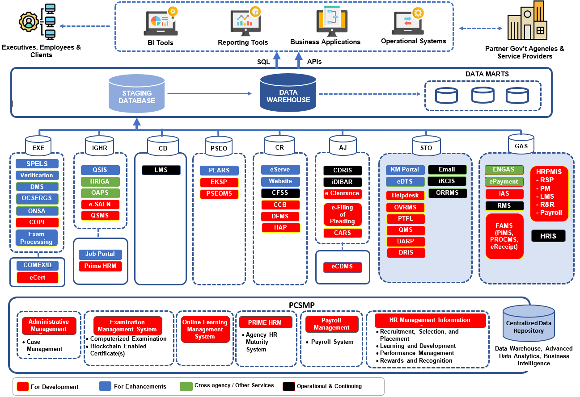
PART II. INFORMATION SYSTEMS STRATEGY

CSC INTEGRATED INFORMATION SYSTEMS (CSC-IIS)

EXAMINATION & ELIGIBILITY (EXE) INFORMATION SYSTEM  - SPELS - Special Eligibilities Information System  - Verification – system related to verification (CSEVS, VCAS, EDQIS)  - CSEVS – Civil Service Eligibility Verification System  - VCAS – Verification, Certification and Authentication System  - EDQIS – Eligibility Query System  - DMS – Document Management System  - OCSERGS – Online Civil Service Exam Result Generation System  - ONSA – Online Notice of School Assignment  - COPI - Correction of Personal Information  - Exam Processing – systems related to exam processing  - COMEX- Computerized Examination (COMEX)  - DEx – Digital Examination  - eCert - electronic Certificate of Eligibility | INVENTORY OF GOVERNMENT HUMAN RESOURCE (IGHR) INFORMATION SYSTEM  - QSIS – Qualification Standards Information System  - HRIGA – Human Resource Inventory for Government Agencies  - OAPS – Online Appointment Processing System  - eSALN - Digitization of Statement of Assets, Liabilities, and Net Worth  - QSMS – Qualification Standards Management System  - JOB Portal – Online listing of vacant positions  - PRIME HRM – Program to Institutionalize Meritocracy and Excellence in Human Resource Management.

PART II. INFORMATION SYSTEMS STRATEGY

CSC INTEGRATED INFORMATION SYSTEMS (CSC-IIS) (cont’d)

CAPABILITY BUILDING (CB) INFORMATION SYSTEM  - LMS – Learning Management System | PUBLIC SECTOR EMPLOYEES’ ORGANIZATION (PSEO) INFORMATION SYSTEM  - PEARS – Process of Employees Association and Recognition System  - EKSP - Education and Knowledge Sharing Portal  - PSEOMS - Public Sector Employee Organizations Management System
CUSTOMER RELATIONS (CR) INFORMATION SYSTEM  - eServe – A one-stop shop desktop/mobile application for CSC Client eServices  - Website  - CFSS – Customer Feedback and Satisfaction Survey  - CCB – Contact Center ng Bayan  - DFMS – Digital Feedback Management System  - HAP – Honor Awards Program | ADMINISTRATIVE JUSTICE (AJ) INFORMATION SYSTEM  - CDRIS – Case Decision and Resolution Information System  - iDIBAR – Integrated Database of Individuals Barred from taking CS examinations and entering government service  - eClearance - electronic Clearance  - eFiling of Pleadings - electronic Filing of Pleadings  - CARS - Cases Adjudication Reporting System  - eCDMS - electronic Case and Document Management System

PART II. INFORMATION SYSTEMS STRATEGY

CSC INTEGRATED INFORMATION SYSTEMS (CSC-IIS) (cont’d)

SUPPORT TO OPERATIONS (STO) INFORMATION SYSTEM  - KM Portal - Knowledge Management Portal  - eDTS – online Data Tracking System  - Helpdesk - IT ticketing support system  - OVRMS – Online Vehicle Reservation Management System  - PTFL – Philippine Tropical Fiber Law Monitoring Tool  - QMS – Quality Management System  - DARP - Data Access Request Portal  - DRIS - Document Routing Information System  - Email - Official CSC email  - iKCIS - Integrated Knowledge Center Information System  - ORMMS - Online Room Reservation Management System | GENERAL ADMINISTRATIVE SERVICES (GAS) INFORMATION SYSTEM  - eNGAS - Electronic New Government Accounting System  - ePayment – LinkBiz of LandBank  - IAS – Internal Audit System  - RMS – Records Management System  - FAMS - Financial and Assets Management System (PIMS, PROCMS, eReceipt)  - eReceipt – Electronic Receipt System  - HRPMIS – Human Resource Payroll Management Information System (HRPMIS). Includes the following:  - RSP – Recruitment, Selection and Placement  - PM – Performance Management  - LMS – Learning Management System  - R&R – Rewards and Recognition  - Payroll – Payroll System

PART II. INFORMATION SYSTEMS STRATEGY

DATA WAREHOUSE
Data Mart – a subset of data warehouse focused on a particular line of business or subject area making specific data available to selected group of users

Philippine Civil Service Modernization Project (PCSMP)
*A project for the whole Philippine government

PART II. INFORMATION SYSTEMS STRATEGY

- DETAILED Description OF PROPOSED INFORMATION SYSTEMS
NAME OF INFORMATION SYSTEM/ SUB-SYSTEM |  | RANK 1:  Executive Monitoring and Management System
DESCRIPTION |  | A CENTRALIZED PLATFORM THAT WILL PROVIDE TOP-LEVEL OFFICIALS WITH REAL-TIME INSIGHTS INTO ORGANIZATIONAL PERFORMANCE, KEY METRICS, AND STRATEGIC INITIATIVES. IT WILL BE A FACILITY TO ACCESS CONSOLIDATED INFORMATION FROM VARIOUS CSC OFFICES RELEVANT TO MEETING THE STRATEGIC GOALS OF THE COMMISSION. THE INFORMATION IS IN THE FORM OF STATISTICAL, FINANCIAL, AND OTHER QUANTITATIVE/ QUALITATIVE ANALYSIS OR IN OTHER FORMS THAT WILL SUPPORT THE EXECUTIVE AND MANAGEMENT LEVEL DECISIONS.
STATUS |  | For development
DEVELOPMENT STRATEGY |  | In-House
COMPUTING SCHEME |  | Network Systems – Wide and Local Area Networking
USERS | INTERNAL | CSC Executive Offices, Head of Offices
 | EXTERNAL
OWNER |  | CSC Executive Offices
PART II. INFORMATION SYSTEMS STRATEGY

B. DETAILED Description OF PROPOSED INFORMATION SYSTEMS

NAME OF INFORMATION SYSTEM/ SUB-SYSTEM |  | RANK 2:  Administrative Justice Service System
DESCRIPTION |  | This seeks to harmonize systems under CSC administrative justice for consistency, efficiency, and fairness in handling administrative cases by aligning procedures, enhancing inter-office coordination, and leveraging digital tools for case management and monitoring.
STATUS |  | For Development
DEVELOPMENT STRATEGY |  | In-house
COMPUTING SCHEME |  | Network Systems – Wide and Local Area Networking
USERS | INTERNAL | CSC CO, CSC ROs, and CSC Fos
 | EXTERNAL | Public
OWNER |  | OLA

PART II. INFORMATION SYSTEMS STRATEGY

B. DETAILED Description OF PROPOSED INFORMATION SYSTEMS

NAME OF INFORMATION SYSTEM/ SUB-SYSTEM |  | RANK 3:  Public Sector Employee Organization (PSEO) Management System
DESCRIPTION |  | A digital platform designed to manage the registration, accreditation, and monitoring of public sector employee organizations (PSEO). The system streamlines processes, ensures compliance with regulations, and enhances transparency and coordination between employee organizations and the CSC.
STATUS |  | For Development
DEVELOPMENT STRATEGY |  | Inhouse
COMPUTING SCHEME |  | Network Systems – Wide and Local Area Networking
USERS | INTERNAL | CSC CO, CSC ROs, CSC Fos
 | EXTERNAL | Public
OWNER |  | HRRO

PART II. INFORMATION SYSTEMS STRATEGY

B. DETAILED Description OF PROPOSED INFORMATION SYSTEMS

NAME OF INFORMATION SYSTEM/ SUB-SYSTEM |  | RANK 4:  Integrated Eligibility and Examination System
DESCRIPTION |  | A UNIFIED SYSTEM THAT MANAGES THE END-TO-END PROCESSES OF CIVIL SERVICE EXAMINATIONS AND ELIGIBILITY GRANTING. IT STREAMLINES APPLICATION, VALIDATION, TESTING, RESULTS PROCESSING, AND ISSUANCE OF ELIGIBILITY, ENSURING EFFICIENCY, ACCURACY, AND IMPROVED USER EXPERIENCE.
STATUS |  | For Development
DEVELOPMENT STRATEGY |  | Outsourcing
COMPUTING SCHEME |  | Network Systems – Wide and Local Area Networking
USERS | INTERNAL | CSC CO, CSC ROs, and CSC Fos
 | EXTERNAL | Public
OWNER |  | ERPO

PART II. INFORMATION SYSTEMS STRATEGY

B. DETAILED Description OF PROPOSED INFORMATION SYSTEMS

NAME OF INFORMATION SYSTEM/ SUB-SYSTEM |  | RANK 5:  Quality Management System
DESCRIPTION |  | A Quality Management System (QMS) is a structured framework of processes, procedures, and responsibilities designed to ensure that an organization consistently meets customer requirements and enhances satisfaction. The QMS project will provide a repository of documented procedures and process management.
STATUS |  | For Enhancement
DEVELOPMENT STRATEGY |  | In-house
COMPUTING SCHEME |  | Network Systems – Wide and Local Area Networking
USERS | INTERNAL | CSC CO, CSC ROs, and CSC Fos
 | EXTERNAL | -
OWNER |  | OAC-HRG

PART II. INFORMATION SYSTEMS STRATEGY

B. DETAILED Description OF PROPOSED INFORMATION SYSTEMS

NAME OF INFORMATION SYSTEM/ SUB-SYSTEM |  | RANK 6:  Human Resource and Payroll Management Information System (HRPMIS)
DESCRIPTION |  | An integrated system that automates and streamlines human resource functions and payroll processing. It manages employee records, appointments, leave, benefits, and salary computations. It manages employee records and human resource transactions from onboarding to offboarding.
STATUS |  | For Enhancement
DEVELOPMENT STRATEGY |  | In-house
COMPUTING SCHEME |  | Network Systems – Wide and Local Area Networking
USERS | INTERNAL | CSC CO, CSC ROs, and CSC Fos
 | EXTERNAL
OWNER |  | OHRMD

PART II. INFORMATION SYSTEMS STRATEGY

B. DETAILED Description OF PROPOSED INFORMATION SYSTEMS

NAME OF INFORMATION SYSTEM/ SUB-SYSTEM |  | RANK 7:  Internal Audit System
DESCRIPTION |  | A digital platform that supports the planning, execution, documentation, and monitoring of internal audit activities. It enhances audit efficiency, ensures compliance with standards, and provides management with insights for risk mitigation, process improvement, and good governance.
STATUS |  | For Development
DEVELOPMENT STRATEGY |  | In-house
COMPUTING SCHEME |  | Network Systems – Wide and Local Area Networking
USERS | INTERNAL | CSC CO, CSC ROs, and CSC Fos
 | EXTERNAL | -
OWNER |  | IAS

PART II. INFORMATION SYSTEMS STRATEGY

B. DETAILED Description OF PROPOSED INFORMATION SYSTEMS

NAME OF INFORMATION SYSTEM/ SUB-SYSTEM |  | RANK 8:  Human Resource Inventory for Government Agencies (HRIGA)
DESCRIPTION |  | This system provides the inventory of human resources in government agencies. This will be an improvement of the system, which will provide dashboards and reports.
STATUS |  | For Enhancement
DEVELOPMENT STRATEGY |  | In-house
COMPUTING SCHEME |  | Network Systems – Wide and Local Area Networking
USERS | INTERNAL | CSC CO, CSC ROs, and CSC Fos
 | EXTERNAL
OWNER |  | IRMO

PART II. INFORMATION SYSTEMS STRATEGY

c. Databases required

All applications will have their own databases:

NAME OF DATABASE |  | 1. Examination and Eligibility (ExE) Databases
GENERAL CONTENTS/DESCRIPTION |  | Data of Civil Service Eligibles (Master List) and Examination results. It also contains records of aspirant or examinee for a Civil Service eligibility.
STATUS |  | Operational and continuing buildup – SPELS, CSEVS, ONSA, EDQIS, VCAS, DMS, OCSERGS, ONSA, COMEX  For buildup – COPI, eCERT, DEx
INFORMATION SYSTEMS SERVED |  | Examination and Eligibility Information System, Inventory of Government Human Resources System (IGHRS), Customer Relations Information System, and Administrative Justice Information System
DATA ARCHIVING/STORAGE MEDIA |  | NAS, External Disk, and Cloud Storage
USERS | INTERNAL | CSC CO, ROs, and Fos
 | EXTERNAL | Government HRMOs and employees, public
OWNER |  | CSC - IRMO, ERPO

PART II. INFORMATION SYSTEMS STRATEGY

c. Databases required

NAME OF DATABASE |  | 2. Inventory of Government Human Resource (IGHRS) Databases
GENERAL CONTENTS/DESCRIPTION |  | - Agency/HR Profile database – Data on agency and HRMO profile  - Plantilla database – Data on agency plantilla positions and personnel incumbents  - Job Vacancies database – Data on agency vacancies  - Qualification Standards database – Data on qualification standards of positions.  - PRIME-HRM database – Data on agency assessment of HR readiness  - OAPS database – Data on appointment processing
STATUS |  | For buildup – D, F Operational, continuing - A, B, C, E
INFORMATION SYSTEMS SERVED |  | Examination and Eligibility System, Inventory of Government Human Resources System (IGHRS), Administrative Justice Information System, Customer Relations Information System
DATA ARCHIVING/STORAGE MEDIA |  | NAS, External Disk, and Cloud Storage
USERS | INTERNAL | CSC CO, ROs, and Fos
 | EXTERNAL | Government HRMOs and employees, public
OWNER |  | CSC - IRMO, HRPSO, OHRMD, ERPO
PART II. INFORMATION SYSTEMS STRATEGY

c. Databases required

NAME OF DATABASE |  | 3. Capability Building Databases
GENERAL CONTENTS/ DESCRIPTION |  | Learning Management System (LMS) database – Data on training modules, schedules, participants, and service providers.
STATUS |  | LMS – operational, continuous data buildup
INFORMATION SYSTEMS SERVED |  | Capability Building Information System, Customer Relations Information System
DATA ARCHIVING/STORAGE MEDIA |  | NAS, External Disk, and Cloud Storage
USERS | INTERNAL | CSC CO, ROs, and Fos
 | EXTERNAL | Government agencies and employees, public
OWNER |  | CSC - CSI, OHRMD

PART II. INFORMATION SYSTEMS STRATEGY

c. Databases required

NAME OF DATABASE |  | 4. Public Sector Employees’ Organization (PSEO) Database
GENERAL CONTENTS/ DESCRIPTION |  | Data on accreditation of government Employees Association from application to grant. Learning materials/resources on PSEO shall also be stored in this database.
STATUS |  | PEARS – Operational, continuing data buildup  PSEOMS, eKSP – for data buildup
INFORMATION SYSTEMS SERVED |  | Public Sector Unionism Information System, Integrated Administrative Justice System, Customer Relations Information System
DATA ARCHIVING/STORAGE MEDIA |  | NAS, External Disk, and Cloud Storage
USERS | INTERNAL | CSC CO, ROs, and Fos
 | EXTERNAL | Public
OWNER |  | CSC – HRRO

PART II. INFORMATION SYSTEMS STRATEGY

c. Databases required

NAME OF DATABASE |  | 5. Customer Relations (CRIS) Databases
GENERAL CONTENTS/ DESCRIPTION |  | Data on various CSC services/products (scheduling, exam/SPELS applications, document requests), customer complaints, feedback, and requests.  Website Database – Collection of general information about the CSC, programs and projects, issuances, including multimedia contents  iTransparency database – data on procurement, approved budget, and SALN
STATUS |  | eServe, Website, CCB, CFSS – Operational, continuing data buildup  DFMS – For data buildup
INFORMATION SYSTEMS SERVED |  | Customer Relations Information System, Examination and Eligibility System,  Administrative Justice Information System
DATA ARCHIVING/STORAGE MEDIA |  | NAS, External Disk, and Cloud Storage
USERS | INTERNAL | CSC CO, ROs, and Fos
 | EXTERNAL | Government HRMOs and employees, public  COA (iTransparency in the CSC website)
OWNER |  | CSC - IRMO, ICTO, ERPO, PAIO

PART II. INFORMATION SYSTEMS STRATEGY

c. Databases required

NAME OF DATABASE |  | 6. Administrative Justice (AJIS) Databases
GENERAL CONTENTS/ DESCRIPTION |  | Data on administrative cases, decisions/resolutions, pleadings and clearances.
STATUS |  | CDRIS, iDIBAR, eClearance, e-CDMS – Operational, continuing data buildup  eFiling – For data buildup
INFORMATION SYSTEMS SERVED |  | Examination and Eligibility System, Inventory of Government Human Resources System (IGHRS), Administrative Justice Information System, Customer Relations Information System
DATA ARCHIVING/STORAGE MEDIA |  | NAS, External Disk, and Cloud Storage
USERS | INTERNAL | CSC CO, ROs, and FOs
 | EXTERNAL | Government agencies and employees, public
OWNER |  | CSC - OLA, IRMO

PART II. INFORMATION SYSTEMS STRATEGY

c. Databases required

NAME OF DATABASE | 7. Support to Operations System Databases
GENERAL CONTENTS/ DESCRIPTION | - KM database – data on knowledge experts and knowledge products  - eDTS database – data on incoming/outgoing communications and corresponding status and action  - CSC Email database – data on incoming/outgoing electronic mails  - iKCIS database – data on existing book and non-book materials in the CSC Library  - ORRMS database – data on room reservation  - HelpDesk database – data on support requests  - OVRMS database – data on vehicle reservation  - PTFL – data on monitoring of Philippine Tropical Fiber Law in government agencies  - QMS – data on documented procedures and process management
STATUS | A, B, C, D, E - Operational, continuing data buildup  F, G, H, I – For data buildup
INFORMATION SYSTEMS SERVED | Web-based Document Tracking System (eDTS), System and Data Integration, AJIS
DATA ARCHIVING/STORAGE MEDIA | NAS, External Disk, and Cloud Storage

PART II. INFORMATION SYSTEMS STRATEGY

c. Databases required

NAME OF DATABASE |  | 7. Support to Operations System Databases (cont’d)
USERS | INTERNAL | CSC CO, ROs, and FOs
 | EXTERNAL
OWNER |  | CSC - IRMO, ICTO, OFAM, CSLO, OAC-HRG

PART II. INFORMATION SYSTEMS STRATEGY

c. Databases required

NAME OF DATABASE |  | 8. General Administrative Services System Databases
GENERAL CONTENTS/ DESCRIPTION |  | Data of CSC employees’ personal and employment, which will be used for the administrative services processes (i.e., Leave Credits, Payroll, Service Record, PDS)  Data on financial, and assets
STATUS |  | Operational, continuing data buildup
INFORMATION SYSTEMS SERVED |  | Internal Human Resource Information System, Human Resource and Payroll Management Information System (HRPMIS)
DATA ARCHIVING/STORAGE MEDIA |  | NAS, External Disk, and Cloud Storage
USERS | INTERNAL | CSC CO, ROs, and FOs
 | EXTERNAL | -
OWNER |  | CSC – OHRMD, OFAM, OSM, CSI

PART II. INFORMATION SYSTEMS STRATEGY

D. NETWORK LAYOUT
D.1 CURRENT NETWORK LAYOUT/DIAGRAM (CO to ROs, FOs and Off-site Employees)

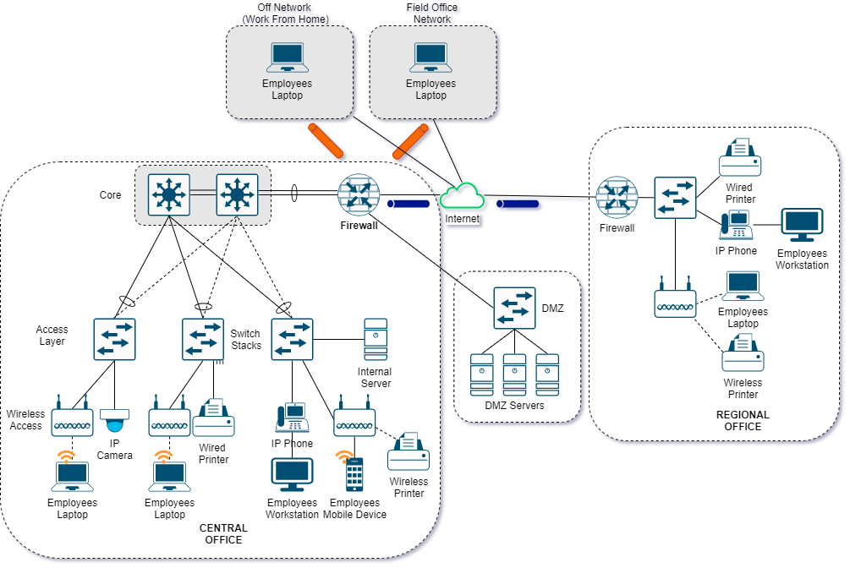
PART II. INFORMATION SYSTEMS STRATEGY

D. NETWORK LAYOUT
D.2 PROPOSED NETWORK LAYOUT/DIAGRAM (CO to ROs, FOs and Off-site Employees)

